Tirana, October 22, 2020

Prot_no
CALL FOR EXPRESSION OF INTEREST
COMPETITION
FOR DESIGNING PROTECTIVE STRUCTURES FOR SAND DUNES (WOODEN FENCES, PASARELLA AND ARTISTIC INSTALATIONS) IN FRAME OF
“WELCOME” PROJECT - WPT3

Location: Albania
Contracting Authority: INSET on behalf of National Coastline Agency, Tirana, Albania
Expected Duration of Execution: November 23, 2020

BACKGROUND
INSET following the implementation of the project “WELCOME”/Code 192, financed by the European Union under the Instrument for Pre-Accession Assistance (IPA) Interreg IPA CBC Italy-Albania-Montenegro 2014-2020, launches the call for designers, artists and architects to participate in a design competition of protective structures for sand dunes.
Ref: Interreg IPA CBC Italy-Albania-Montenegro 2014-2020, “WELCOME”, 1st call for standart project/ code.250/ Order nr. 48, Prot, nr. 642, date 28.10.2019.
Contract Title: “External Expertise – Organization of a competition to design protective structures for sand dunes”, to support the Natonal Coastline Agency, in implementing WELCOME project.
The objective is planning an anti-erosion coastal system including art-driven reuse of wooden marine litter to be placed on a specific stretch of coastline. It will consist in an artistic competition and a working protocol of artistic waste recycling and recovery techniques for the reuse of beached vegetable biomass (first and foremost wood) in dune system management. The artistic work will reuse of woody debris from ML in the dune consolidation: this approach to solve the dune restoration issue will be easily transferred to other coastal areas due to the combination of its capacity to increase the attractiveness of the beaches as well as its circular economy-based approach.
“WELCOME” is a project that will address the cross-border territorial challenges concerning ML management and coastal dune consolidation in Albania - Velipoja area, Kepi i Rodonit, Lalzi Bay. The coasts of Italy, Albania and Montenegro share the same impact on ecosystems and biodiversity due to ML problems and coastal erosion that have mainly been imposed as a result of anthropogenic impact such as sea level rise as a result of global warming, land use changes, harbors and coastal defense structures, etc.

OBJECTIVE AND COMPETITION SPECIFICATIONS
INSET with the final beneficiary National Coastline Agency invites all artists, designers and architects to submit proposals for designing and preparing a working manual of art structures on the beaches. Artistic installations should be made of natural and processed wood collected during beach cleaning activities. Artistic installations along with wooden fence and pasarellas will contribute to raising public awareness on the importance of marine litter and dunes.
LOCATION
The activities on protection and revitalization of sand dunes will be implemented on the beaches located in the two municipalities, Shkodra Municipality (Velipoja) and Durres Municipality (Cape of Rodoni and the Bay of Lalzi). Specifically, there are selected two areas in Velipoja beach. The first lies in the center of Velipoja and the second lies on the beach of Viluni near the lagoon of Viluni. On the beach of Lalzi Bay, are selected two areas with differences in geographical extension characteristics. The first lies at the bottom of Lalzi Bay beach and the second lies on Hamallaj Beach. Likewise, on the Cape of Rodon are selected two areas, one on the beach near St. Anthony’s Church and one in the area of the castle.

The maps for the specific areas are found in Annex 1.

COMPETITION AND ARTISTIC WORKS
Artists, designers, architects interested in participating in this competition must work on the design of protective structures for sand dunes in the specified areas, such as fences, pasarellas and artistic installations. Protection of dunes from erosion and anthropogenic impact in the areas specified above will be achieved by erecting a wooden fence around the dune while pasarellas are the solution to enter the beach where it is not possible through the dunes. Structures should be designed using natural wood collected in the framework of the WELCOME project, so as not to harm the environment.
The materials that are allowed to be used for this design are:
a. Natural and/or treated wood (at least 60% of the wood used for installations must be marine litter collected from beach cleaning activities).
b. Binding and construction materials (rope, fabric and other natural materials, avoiding the use of screws and any other metal material)
c. Materials for decorating the structure (stone, gravel, fabrics, ropes with natural fibers and similar natural materials).
d. Artistic installations that will serve as protective structures should be easily collapsible, mobile and resistant to weather conditions such as rain and wind.
The wood collected from the cleaning actions will be used for the construction and installation of the protective structures.
SELECTION PROCESS
INSET in collaboration with the National Coast Agency in Albania will appoint a commission of 3 (three) members, which after submitting the works on the proposed solution models, will review and evaluate the proposed solutions. The evaluation criteria are:
1. Originality and innovation of the proposed project of artistic structures [max 25/100];
2. Use of natural material in the erection of structures: [max 25/100];
3. Ability of the project to meet the functional needs (protection of dunes and tourist attraction): [max25 / 100];
4. Compatibility of the solution with the beach landscape [max 25/100];
This commission will award the following three prizes:
• First Price - € 500.00
• Second Price - € 300.00
• Third Price - € 200.00
By awarding prizes for First, Second and Third place, INSET and the National Coast Agency buys all copyrights for the works.
APPLICATION
Designers, artists and architects interested in participating in this competition, are invited to work on the design of artistic installations, fences and pasarellas for coastal protection against erosion in accordance with the protocol defined by the project partners "WELCOME".
Interested participants are invited to submit the works in envelopes to the address: Str. Him Kolli, no 46, Tirana, Albania and they have to send them by e-mail at albaniainset@gmail.com.
On the back of the envelope should be written:
"Competition for the design of protective structures for sand dunes”
Project: WELCOME
The envelope must contain 2 (two) sealed envelopes as follows:
"Envelope A - Administrative Documents"
"Envelope B - Proposal for the Design of Protective Structures for the Preservation of Sand Dunes on the beaches”.
Envelope A must contain:
- Expression of interest (Annex 2)
- Photocopy of the identity document of the participant (identity card or passport).
- Curriculum Vitae.
In case the envelope A "Administrative Documentation" does not contain all the listed elements, participation in the competition is rejected.
Envelope B must contain:
- Graphic provision
- Fence chart - segment / field 1: 25 / 1:10
- Graphical representation of the band - segment 1: 25 / 1:10
- Longitudinal and cross sections with dimensions of fence and barrier 1: 25/1: 10
- Design / Connection Details 1: 10/1: 5
- Mounting diagrams
- 3D view (illustrations of fences and banners in 3D from all angles, model photos)
- Technical description which should be presented in A4 paper up to 10 pages. It can contain both text and images and should include a description of the design in relation to the objectives of the WELCOME project, as well as a description of the material used for the structures in question. Furthermore, the technical description should include static safety of the designed structures, durability during and after completion of the work.
- Financial analysis which should be reflected in A4 paper, with an unlimited number of sheets. Prices should be calculated based on current market prices in Albania together with T.V.SH.
In case the envelope B - "Design Proposal of Protective Structures for the Preservation of Sand Dunes on the beaches” does not contain all the listed elements, participation in the competition is rejected.
LANGUAGE
All documents to be submitted must be in Albanian or English.
The deadline for submission is November, 23, 2020.

QUESTION AND ANSWER
All questions related to the competition can be sent within a maximum of three days from the deadline for the competition to the address albaniainset@gmail.com. Any questions received after the deadline will be ignored.

Annex 1
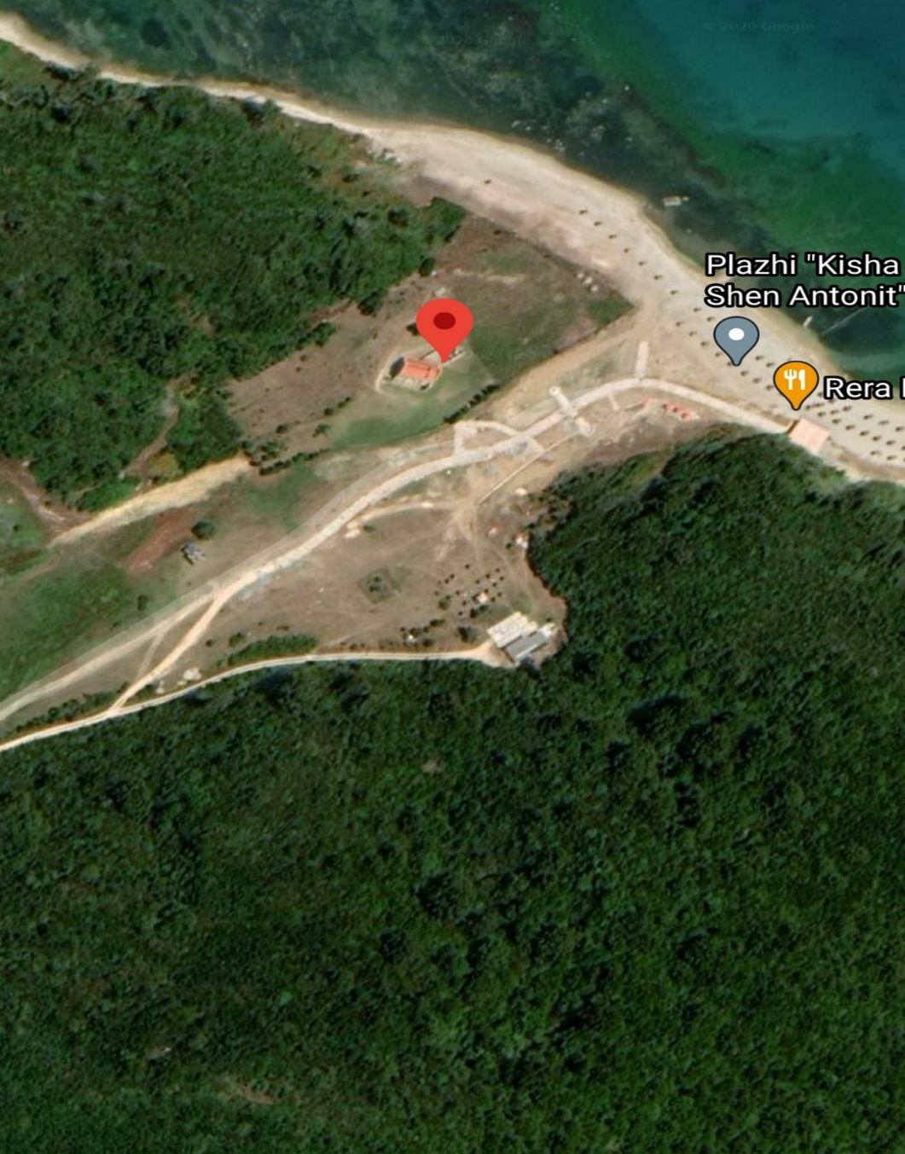

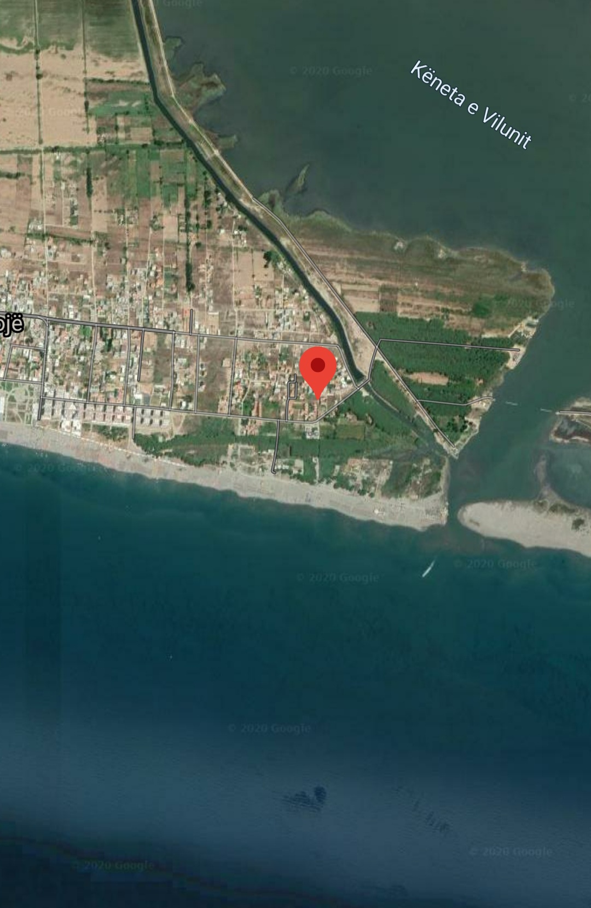

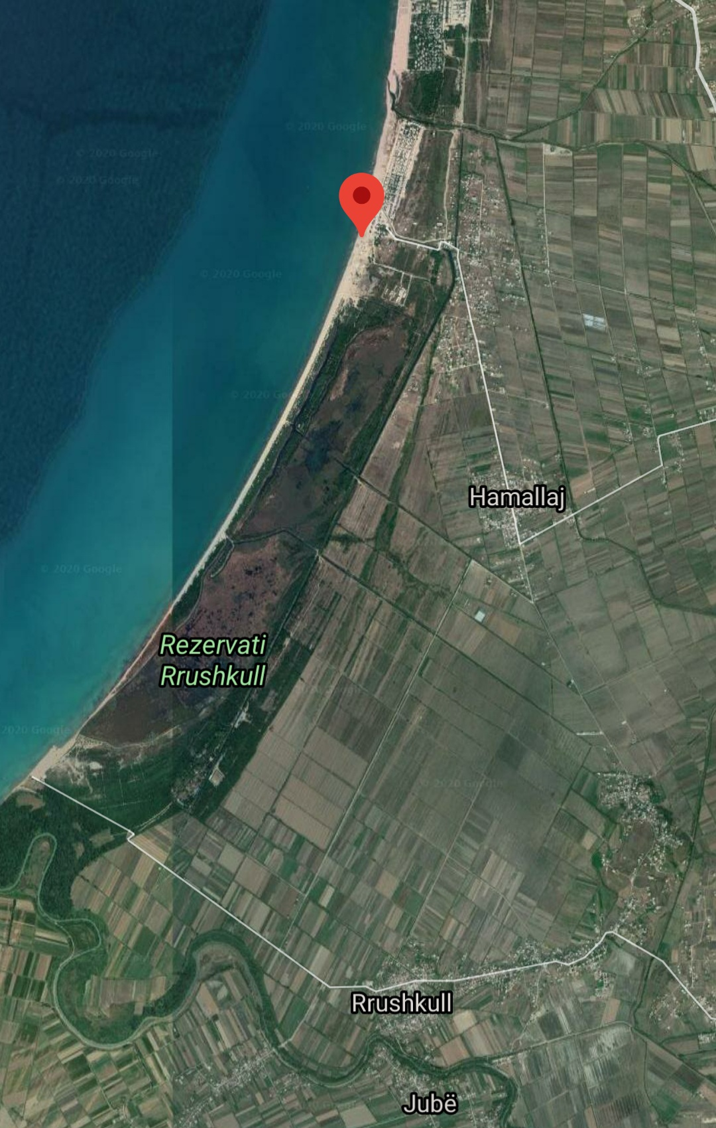

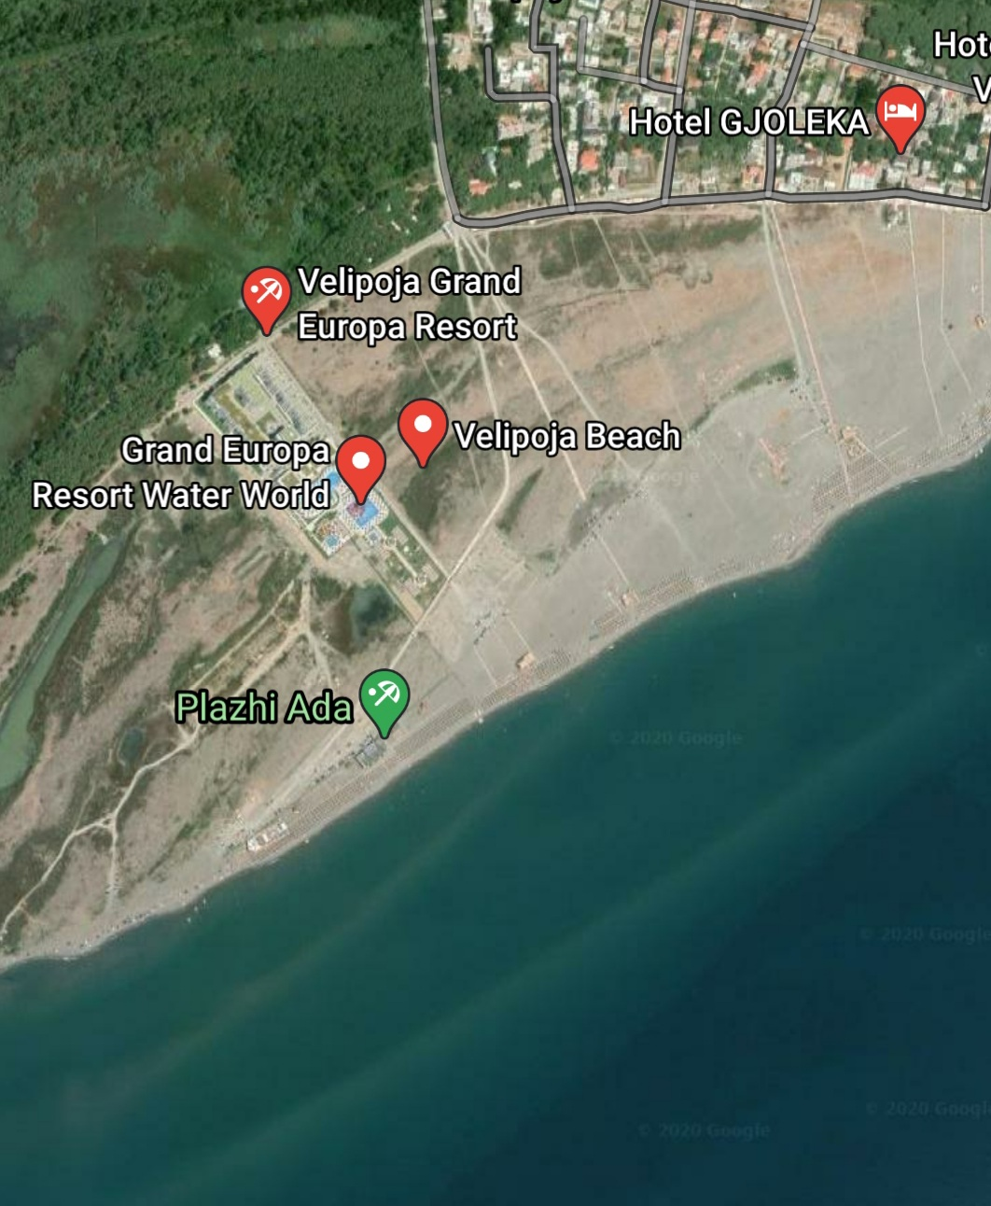
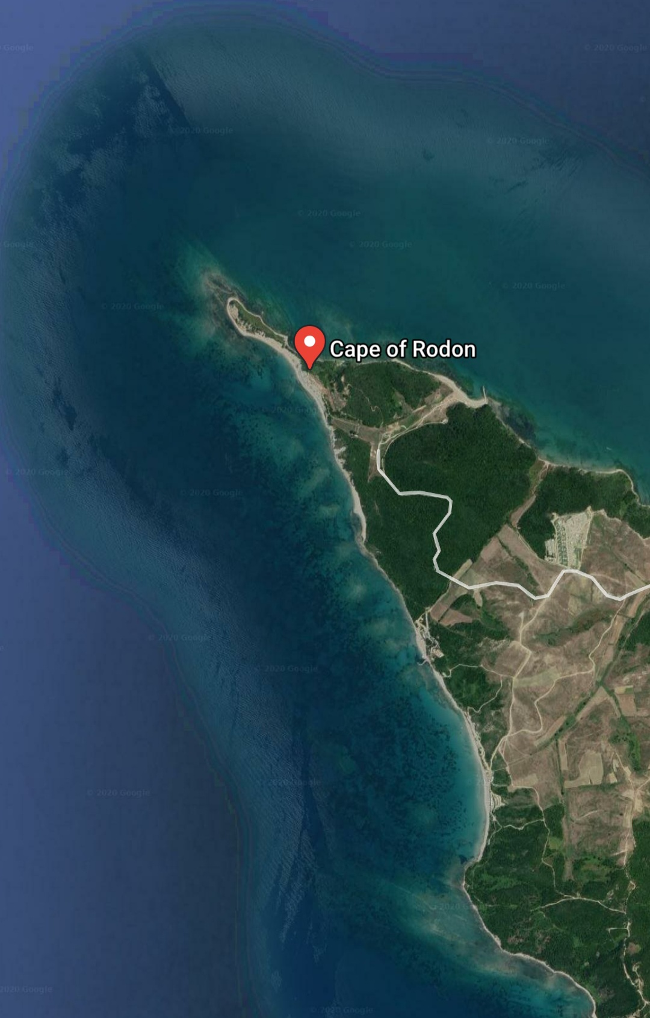

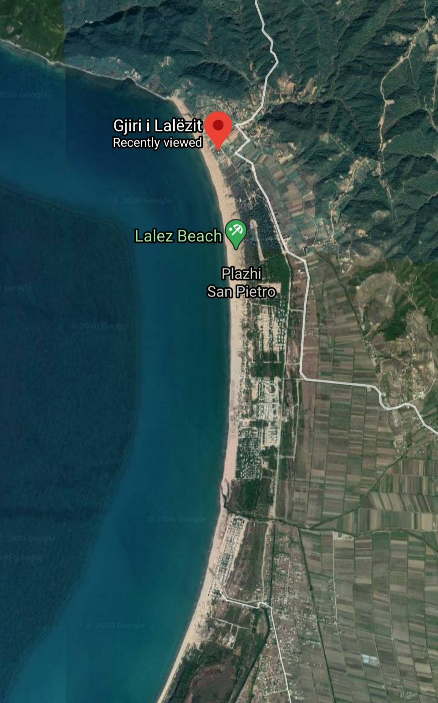

Annex 2

Date, __.__.____

Expression of Interest
Competition for designing protective structures for sand dunes (wooden fences, pasarella and artistic instalations) in frame of “WELCOME” PROJECT - WPT3

Dear Sir/Madame,
I hereby declare the interest to participate in the competition organized by INSET on behalf of the final beneficiary National Coastline Agency.
I declare and avow that the artwork I am submitting to you is my own original work and was not copied from other artists.
My personal information as following:
Name: _____________________
Surname: __________________
E-mail: ____________________
Telephone: ___________________
Adress: ________________________________

Sincerely,
____________

